*Florida International University*

*School of Computing and Information Sciences*

CIS 4911 - Senior Capstone Project

Software Engineering Focus

Feature Document

User Story # 596

**Team Member:**

Garrett Lemieux

**Product Owner(s)**:

Francisco Ortega

**Mentor(s)**:

Francisco Ortega

**Instructor**: Masoud Sadjadi

# 

# **User Story**

* As a User I would like feedback when I switch drawing modes using the Leap Motion device and interact with UI so I know intended actions with Leap Motion were successful.

## **Use Case**

User want to change the shape being drawn or the color being drawn or save the current canvas by using leap gestures.

* Details:
* Actor:
  + User
* Pre-conditions:
  + TouchPoint app is running.
  + Leap motion and multi touch devices are connected.
* Description:
  + Use case begins when User has decided to change the shape or color being drawn or wants save the current canvas using leap motion gestures. of the line or color of the line to be drawn when using leap motion.
  + User performs a swipe gesture when he or she wants to change current drawing color.
  + User performs a swipe circle gesture when he or she wants to change current shape being drawn.
  + User performs a keyboard tap gesture when he or she wants to save current canvas.
  + Use case ends once the user finishes performing a gesture.
* Post-conditions:
  + The shape or color has changed or the canvas has been saved depending on the gesture used with the leap motion.
* Alternative Courses of Action:
  + User can perform a swipe vertically or horizontally to change color to be drawn.
  + User can do a clockwise or counterclockwise circle gesture to change the shape to be drawn.
* Decision Support:
  + Frequency: High , User will need to vary his or her shapes and colors used to when drawing and he or she will need to save the canvas they are working on.
  + Criticality: High , Allows Users to draw different designs by changing shapes and colors using leap gestures. Also will be able to save a canvas without the need of multi touch device.
  + Risk: Medium, Had gesture recognition implemented but needed to integrate the shape and color change functions to work for both multi touch and leap motion devices.
* Constraints:
* Usability:
  + Need to learn how to perform leap gestures correctly.
* Reliability
  + High
* Performance
  + Performance High , low failure
* Supportability
  + Leap Motion Device
* Modification History:
  + Owner: Garrett Lemieux
  + Initiation Date 02/21/2015
  + Date last Modified: 02/28/2015

## 

## 

**Sequence Diagrams**

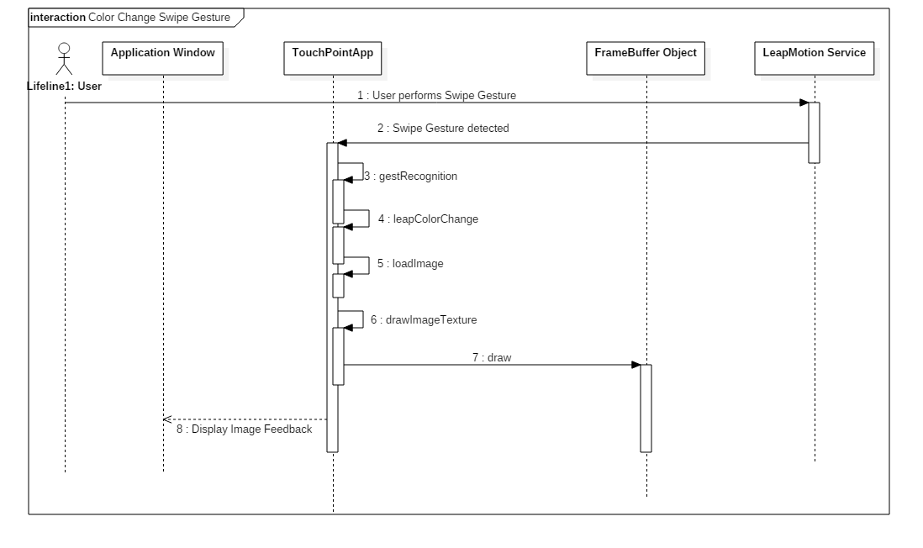

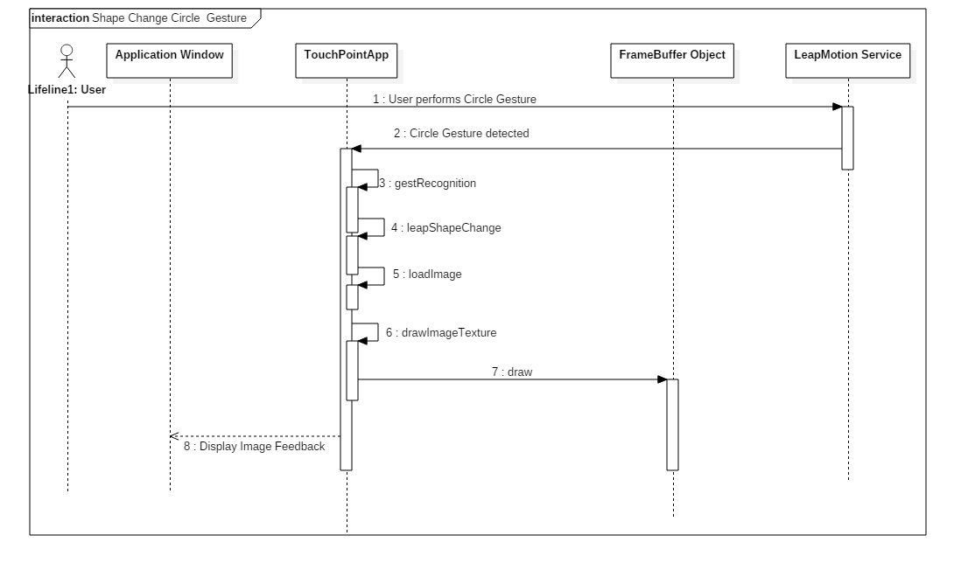

## 

## 

## 

## 

## 

## 

## 

## 

## 

## 

## 

## 

## 

## 

## 

## **Class Diagram**

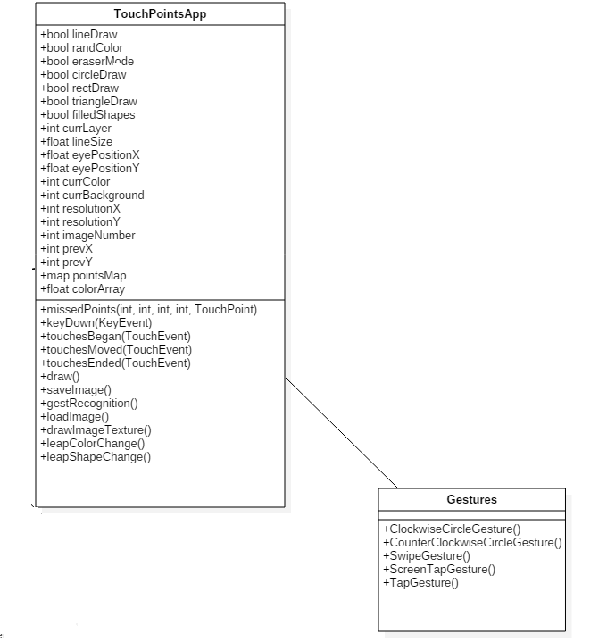

## **Unit Test**

* Sunny Day Test:
  + User wants to change shape being drawn by both devices.
    - He or she performs circle gesture in clockwise direction.
    - He or she performs circle gesture in counter clockwise direction.
  + User wants to change color being drawn by both devices.
    - He or she performs swipe gesture in a left to right horizontal direction.
    - He or she performs swipe gesture in a right to left horizontal direction.
    - He or she performs swipe gesture in a top to bottom vertical direction.
    - He or she performs swipe gesture in a bottom to top vertical direction.
  + User wants to save current canvas
    - He or she performs keyboard tap gesture.
* Rainy Day Test:
  + User tries to perform gesture before feedback image has faded away
    - Systems only allows one gesture to be recognized at a time
  + User performs incorrect gesture
    - System will not read gesture and no action will take place
  + User performs same gesture twice in a row before drawing
    - System will read both calls and make necessary changes depending on gesture.

## **Integration Testing**

* The ability to use change of shape and color functions works in TouchPointsApp.cpp when
  + When swipe and circle gesture are recognized by leap motion.
  + Both devices now are set to same shape and color and either device can be used to draw set shape and color.
  + When keyboard tap gesture is recognized canvas drawn by either device is saved.
* Both devices can work at same time and any change done by either device makes changes occur to both devices when drawing.

## **User Guide**

* Once a user has decided to change the current shape that will be drawn by either device he or she must perform a circle gesture.
  + In order to perform a circle gesture user's hand must be in the field of the leap motion. He or she starts to draw a circle in either clockwise or counterclockwise direction.
  + The gesture is made by holding hand and wrist steady and using your index finger. Once a full circle has been created the gesture will be recognized.
  + A successfully read gesture will perform an the desired action and a picture will appear providing feedback to the user.
  + The feedback image will slowly fade out.
  + No other gesture may be read during that time.
* Once a user has decided to change the current color that will be drawn by either device he or she must perform a swipe gesture.
  + In order to perform a swipe gesture user's hand must be in the field of the leap motion. He or she starts to perform a swipe by starting at either the left or right side of leap motion.
  + The gesture is made by holding hand and wrist steady and using your index to demonstrate a swipe by moving arm from left to right or right to left depending on starting position of hand. Once a full swipe has been created the gesture will be recognized.
  + The swipe gesture can be made in the vertical direction as well following the same direction but in the y axis instead of the x axis.
  + A successfully read gesture will perform an the desired action and a picture will appear providing feedback to the user.
  + The feedback image will slowly fade out.
  + No other gesture may be read during that time.
* Once a user has decided to save his or her canvas a keyboard tap gesture must be done.
  + In order to perform a keyboard tap gesture user's hand must be in the field of the leap motion. He or she starts to perform by holding hand and wrist steady and using your index to simulate the pressing of a keyboard.
  + A quick movement downward with finger will perform a keyboard tap gesture.
  + A successfully read gesture will perform an the desired action and a picture will appear providing feedback to the user.
  + The feedback image will slowly fade out.
  + No other gesture may be read during that time.